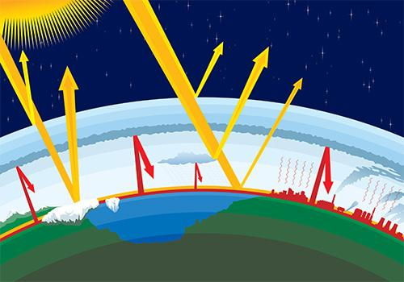
Background:
The greenhouse effect is the rise in temperature that the Earth experiences because greenhouse gases trap energy from the sun.

Sunlight enters the Earth's atmosphere, passing through the blanket of greenhouse gases. The Earth's surface absorb the sunlight’s energy. Once absorbed, this energy is sent back into the atmosphere. Some of the energy passes back into space, but much of it remains trapped in the atmosphere by the greenhouse gases, causing our world to heat up.

Without the greenhouse effect, the Earth would not be warm enough for humans to live. But if the greenhouse effect becomes stronger, it could make the Earth warmer than usual. Even a little extra warming may cause problems for humans, plants, and animals.

Scientists think that the things people do that send greenhouse gases into the air are making our planet warmer.

Question: ______________________________________________________________________________

______________________________________________________________________________________

Independent variable:____________________________________________________________

Dependent Variable:_____________________________________________________________

Hypothesis:_____________________________________________________________________________

______________________________________________________________________________________

Materials Needed per group:
- Shop lamp with 150W spot light bulb
- 2 - clear 2 liter bottles with top ⅓ removed
- 2 cups sand (the same color and mixture)
- Plastic wrap to cover top of 2-L bottle
- 1 rubber band (to secure plastic wrap over bottle)
- 2 thermometers
- Tape to secure thermometers in bottles

Procedure:
1) Take the temperature of the inside both 2-liter bottles. On the data table, record the “start” temperature for the 2-liter bottle with an atmosphere (covered with plastic wrap) and the 2-liter bottle without an atmosphere (no cover).
2) Make sure that the light bulbs are the same distance from the top of the sand in the bottles. Turn the shop lights on.
3) After 2 minutes record the temperature of each of the 2-liter bottles on the data table (as indicated in step 1).
4) Repeat step 3 every 2 minutes for 22 minutes.

Data Table:
Time | start | 2 minutes | 4 minutes | 6 minutes | 8 minutes | 10 minutes
Atmosphere
No Atmosphere
Time | 12 minutes | 14 minutes | 16 minutes | 18 minutes | 20 minutes | 22 minutes
Atmosphere
No Atmosphere
Make a graph of your data on the attached page.

Diagram: (Sketch the setup of the experiment)

Graph Title

____________________________________________________________________________

____________________________________________________________________________

X:__________________________________________
Y

Conclusion:
- What is the greenhouse gas effect?

- What is the purpose of this experiment?

3) What is the objective of this lab? (Summarize the procedures and the setup used to test your hypothesis).

4) What were your major findings?

5) Was your hypothesis supported by data?

6) How could mistakes with your data occurred during this lab?

7) What new experiment (or how could be change this experiment) could continue the study of the greenhouse gas effect?

