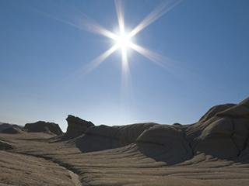
Global Temperature Rise
The planet's average surface temperature has risen about 1.62 degrees Fahrenheit (0.9 degrees Celsius) since the late 19th century, a change driven largely by increased carbon dioxide and other human-made emissions into the atmosphere.⁴ Most of the warming occurred in the past 35 years, with the five warmest years on record taking place since 2010. Not only was 2016 the warmest year on record, but eight of the 12 months that make up the year — from January through September, with the exception of June — were the warmest on record for those respective months. ⁵

Earth’s Vital Signs:Global Temperatures
- Between the years of 1884 and today, what is the overall temperature anomaly over time?

2) How do the change in the overall temperature anomaly over time and the time lapse series relate to one another?

Global Climate Changes: Causes
1) What is the greenhouse gas effect?

2) What are “feedbacks”?

3) List the five greenhouse gasses and describe their contribution to the greenhouse gas effect.

4) How will strengthening the greenhouse gas effect change the planet?

5) How do humans change the Earth’s natural greenhouse?

6) What is solar irradiance? Is it a reasonable explanation for increasing atmospheric temperatures?

