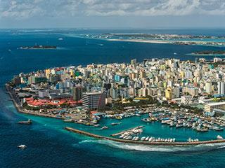
Sea level rise
Global sea level rose about 8 inches in the last century. The rate in the last two decades, however, is nearly double that of the last century and is accelerating slightly every year.¹⁰

Image: Republic of Maldives: Vulnerable to sea level rise

Earth’s Vital Signs: Sea Level
- What are the two primary contributing factors to rising sea levels?

- How much have sea levels risen since the beginning of 1993?

- Take the Sea Level Quiz. What was the most interesting thing you learned taking the quiz?

