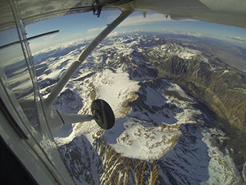
Decreased snow cover

Satellite observations reveal that the amount of spring snow cover in the Northern Hemisphere has decreased over the past five decades and that the snow is melting earlier.⁹

Earth Observatory: Snow Cover
- How does snow regulate climate?

2) Explore the National Snow and Ice Data Center. What is one interesting thing that you learned from the maps?

