Name ___________________________________

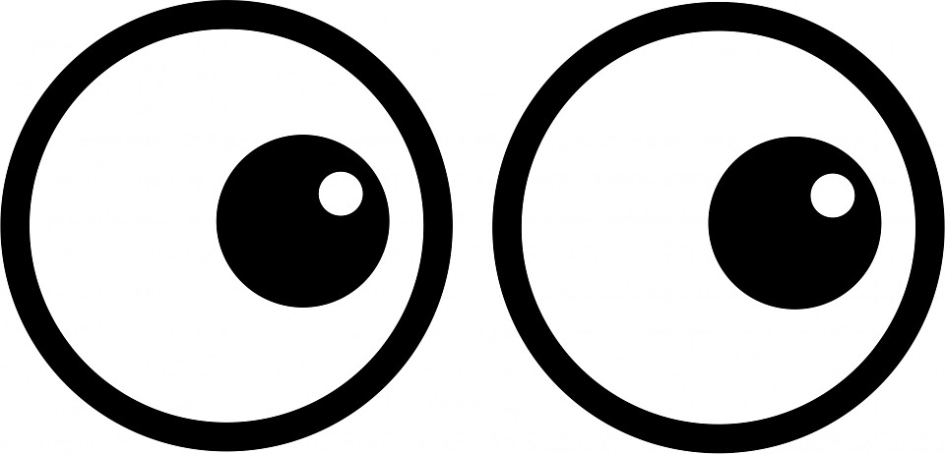
See  What do you observe? | Think  Can you explain what is happening? | Wonder ?  What questions do you have?

