Background: Today you are going to estimate a number of wind turbines that Talent might need in order to meet future energy requirements. According to the City of Talent , Clean Energy Action Plan, in 2015 the City of Talent used 37 gigawatt hours of energy, 71% of which were residential. According to the US Census, in 2010 the population of Talent was 6066 and was projected to be 6492 in 2017. The average household is 2.14 people.

Small turbines produce less than 1 kw/sec and have a sweep area less than 200$m^{2}$.
In order to convert kinetic energy into electrical energy, small turbines typically require a minimum wind speed of 4 m/s.

In order to calculate the amount of energy that a wind turbine can generate you will need to know the average wind speeds, the number of hours that the wind blows at each speed during an average year, and the seep area of the turbine.

Table 1. Average wind speeds for Medford

Note: Percents reflect the hours between
5 am and 8 pm starting Jan. 1, 2018 and ending Dec. 31, 2018.

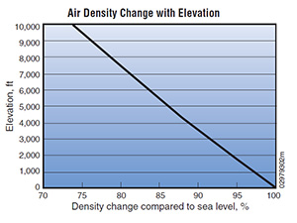
In order to estimate the amount of power that each wind turbine might generate, use the following formula: P= $C_{p}$$\frac{1}{2}$𝞺A${V^{3}}^{}$
Where:
P = Power output, watts per second
ρ = Air density, kg/${m^{3}}^{}$
(at sea level air density is 1.23 kg/${m^{3}}^{}$)
A = Rotor swept area
( π = 3.1416, radius in meters)
V = Wind speed, m/s
$C_{p}$ = Maximum power coefficient, ranging from 0.25 to 0.45 (varies with wind speed)

A German physicist Albert Betz concluded in 1919 that no wind turbine can convert more than 16/27 (59.3%) of the kinetic energy of the wind into mechanical energy turning a rotor, known as the Betz Limit or Betz' Law. Therefore, the theoretical maximum power efficiency of any design of wind turbine is 0.59 (59% of the energy carried by the wind can be extracted by a wind turbine). This is called the “power coefficient.” The $C_{p}$ value is unique to each turbine type and is a function of wind speed that the turbine is operating in and values of 0.35 - 0.45 are common even in the best designed wind turbines.

Question: How many wind turbines will Talent need to meet future energy demands?

